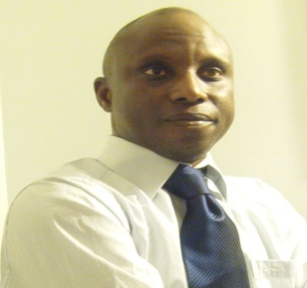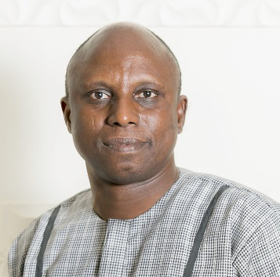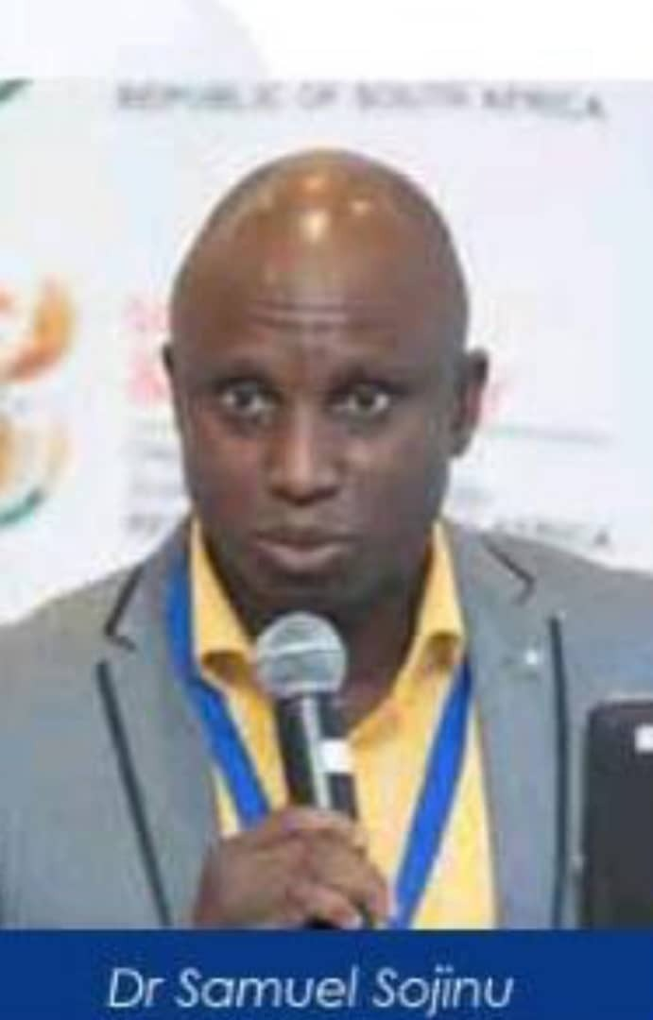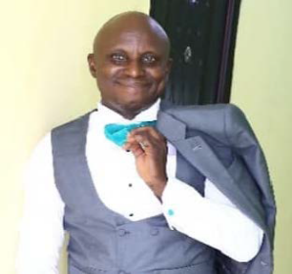
Sojinu Olatunbosun Samuel is currently a Professor of Organic Geochemistry of the Department of Chemistry/Geology, Federal University of Agriculture, Abeokuta, Nigeria and an Adjoint Professor with a number of local and foreign Universities and Research Institutes. He is a seasoned Organic Geochemist with over seventy scientific articles in internationally reputable journals. He has been invited for talks and also made presentations at scientific meetings in countries like South Africa, China, Germany; Puerto Rico, USA; Canada among others and likewise acts as resource person for a yearly training of the Nigerian Institute of Science Technology, Federal Ministry of Science and Technology, Nigeria. He was recently involved in a joint project on Green Economy and Waste Management by Inter Academy Partnership/Global Young Academy, involved in book projects with Network of Academies of Sciences in Africa and UNEP-SEI Africa Report. He is a member of screening comittee for a number of International grant awarding bodies and Continental Report such as AAS Climate Change Grant (100,000USD),etc.
He has won prestigious academic laurels and grants such as International Foundation for Science grant for individual scientist, National Science and Engineering Research Council of Canada Visiting Fellowship award at Health Canada, The World Academy of Sciences-Chinese Academy of Sciences (TWAS-CAS) Postdoctoral Fellowship Award at the State Key Laboratory of Organic Geochemistry, Guangzhou Institute of Geochemistry, China; University of Pretoria Vice-Chancellor’s Postdoctoral Fellowship Grant Award, CAS-TWAS Postgraduate Fellowship Award at the State Key Laboratory of Organic Geochemistry, Guangzhou Institute of Geochemistry, International Union of Pure and Applied Chemists (IUPAC) young scientist award, Federal government of Nigeria undergraduate scholarship, Lagos State government scholarship among several others. He was selected in 2015 as Next Einstein Forum Ambassador for Nigeria. He has been involved in a number of joint collaborative researches on various issues of international concerns. He was an Executive committee member of the Global Young Academy and held many administrative positions both home and abroad in reputable organizations.
He has won over twenty international awards and travel grants which enabled him to visit over 30 countries on paid trip.
At the Federal University of Agriculture, he has held administrative positions and currently the Head of Department of Geology.
He is a Fellow/member of a number of notable international organizations such as the Global Young Academy, Nigeria Young Academy, America Chemical Society, the Chemical Society of Nigeria, Institute of Chattered Chemists of Nigeria and Nigerian Association of Petroleum Explorationist and served in various capacities in these organizations. He is currently focusing on Climate change, environmental forensic studies, synthensis of novel drug candidates, biomarkers signalling in geochemical samples, emerging pharmaceutical pollutants and bio/phytoremediation studies. He has successfully supervised over 100 undergraduate students, served as internal/external examiner for a number of postgraduate examinations and has supervised eight (8) PhD students as the major supervisor. He is happily married with children.

